Victor Nguyen

Professor Hadaegh

CS 443

24 March 2020

Assignment 2

**1.** SELECT OFFICE, CITY, REGION, MGR, TARGETS, SALES

FROM OFFICES ORDER BY OFFICE ASC

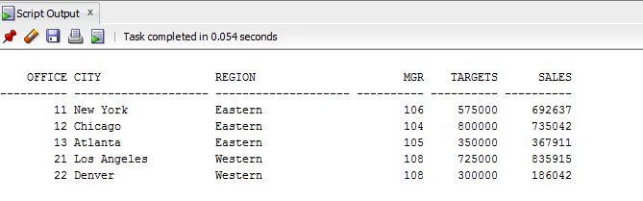

**2.** SELECT PRODUCT_ID, MFR_ID, DESCRIPTIONS, QTY_ON_HAND, PRICE

FROM PRODUCTS WHERE MFR_ID = 'ACI' ORDER BY PRICE DESC

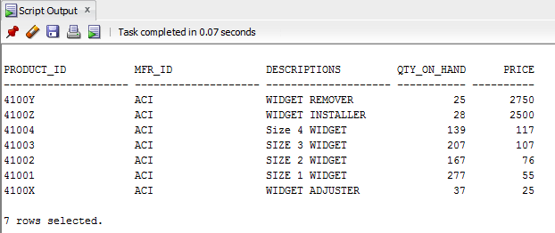

**3.** SELECT ORDER_NUM, ORDER_DATE, CUST, REPS

FROM ORDERS WHERE PRODUCT='XK47' OR PRODUCT='773C'

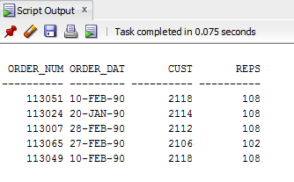

**4.** SELECT NAMES, AGE

FROM SALESREPS WHERE REP_OFFICE IN (12, 21, 13)

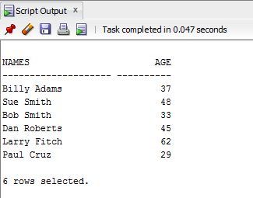

**5.** SELECT NAMES

FROM SALESREPS WHERE SUBSTR(NAMES, 2, 1)='o'

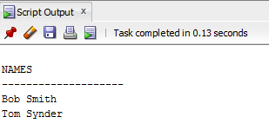

**6.** SELECT EMPL_NUM, NAMES

FROM SALESREPS WHERE REP_OFFICE IS NULL

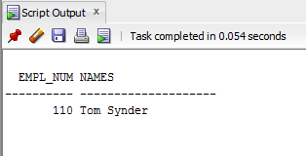

**7.** SELECT NAMES

FROM SALESREPS

WHERE NAMES LIKE '%Smith%'

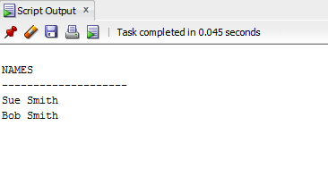

**8.** SELECT DISTINCT TITLE

FROM SALESREPS

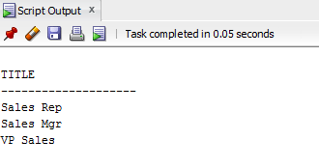

**9.** SELECT DISTINCT DESCRIPTIONS

FROM PRODUCTS WHERE LENGTH(DESCRIPTIONS)>6 AND LENGTH(DESCRIPTIONS)<=10

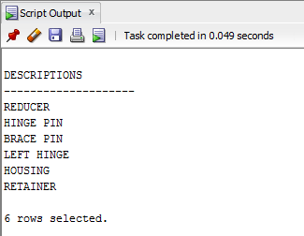

**10.** SELECT ORDER_NUM, REPS, CUST

FROM ORDERS

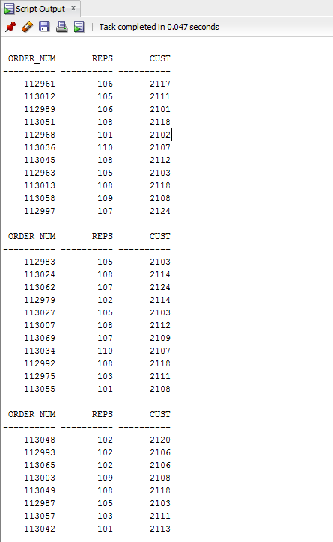

**11.** SELECT MFR_ID, PRODUCT_ID, COMPANY, PRICE

FROM CUSTOMERS, ORDERS, PRODUCTS

WHERE MFR_ID = MFR

AND PRODUCT_ID = PRODUCT

AND CUST = CUST_NUM

AND AMOUNT < 3000

AND CUST IN (2111,2112,2105,2119)

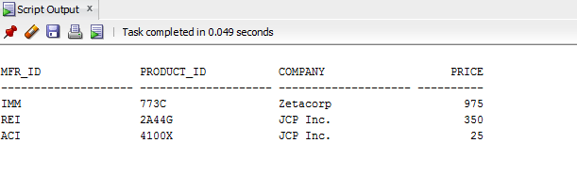

**12.** SELECT EMPL_NUM, NAMES

FROM SALESREPS WHERE (SALES >= 0 AND AGE >= 45)

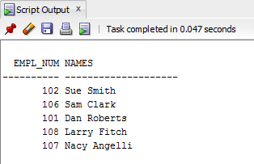

**13.** SELECT CUST_NUM, COMPANY, CREDIT_LIMIT, ORDER_NUM

FROM CUSTOMERS, ORDERS

WHERE CREDIT_LIMIT - AMOUNT <= 5000

AND CUST = CUST_NUM

ORDER BY CUST_NUM DESC

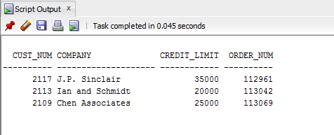

**14.** SELECT SALESREPs.NAMES, MANAGERS.NAMES

FROM SALESREPS, MANAGERS

WHERE SALESREPS.MANAGERS = MANAGERS.EMPL_NUM

AND SALESREPS.AGE >= MANAGERS.AGE

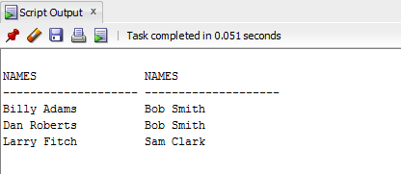

**15.** SELECT NAMES, CITY

FROM SALESREPS, OFFICES

WHERE SALESREPS.SALES < QUOTAS AND OFFICES.SALES < TARGETS

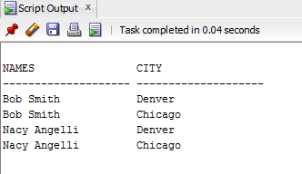

**16.** SELECT NAMES, EMPL_NUM, HIRE_DATE

FROM SALESREPS, ORDERS

WHERE SALES > QUOTAS

AND REPS = EMPL_NUM

AND CUST IN (2117,2111, 2101)

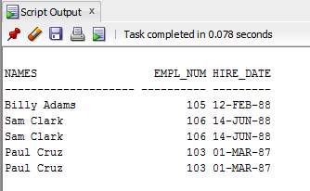

**17.** SELECT ORDER_NUM, COMPANY, NAMES, REP_OFFICE, CITY

FROM ORDERS, SALESREPS, OFFICES, CUSTOMERS

WHERE AMOUNT >= 25500

AND CUST_NUM = CUST

AND REP_OFFICE = OFFICE

AND REPS = EMPL_NUM

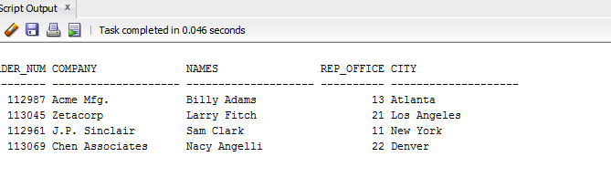

**18.** SELECT ORDER_NUM, SALESREPS.NAMES, MANAGERS.NAMES

FROM ORDERS, SALESREPS, MANAGERS, OFFICES

WHERE MANAGERS.REP_OFFICE = OFFICE

AND CITY = 'New York'

AND SALESREPS.MANAGERS = MANAGERS.EMPL_NUM

AND REPS = SALESREPS.EMPL_NUM

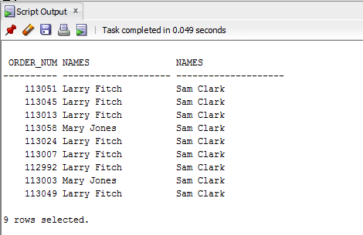

**19.** SELECT MFR_ID, PRODUCT_ID, DESCRIPTIONS, CUST_NUM, COMPANY, ORDER_NUM, ORDER_DATE

FROM CUSTOMERS, ORDERS, PRODUCTS

WHERE AMOUNT < 700

AND MFR = MFR_ID

AND PRODUCT = PRODUCT_ID

AND CUST = CUST_NUM

ORDER BY ORDER_DATE

